CEBU INSTITUTE OF TECHNOLOGY
UNIVERSITY

COLLEGE OF COMPUTER STUDIES

Software Design Description
for
LIC Gateway Data Counter

Signature

Development Team:

ESPINIDO, GLAZE
Project Lead/Developer

ABELLAR, MICHAEL VINCENT
Web Designer/Developer

SANTILLAN, BABYLEN
Programmer Analyst

PARDILLO, REN REN
Tester/Documentation Officer

Change History

Date | Version | Description | Author
08/18/2014 | V0.1 | First draft of the document | Capacio, Bacalso, Aranduque, Verame
10/8/14 | V0.2 | Finalization | Nicholate Rose Verame

Preface

This document is a representation of a software system that is used as a medium for communicating software design information. SDD plays a pivotal role in the development and maintenance of software systems. During its lifetime, a given design description is used by project managers, quality assurance staff, configuration managers, software designers, programmers, testers, and maintainers. Each of these users has unique needs, both in terms of required design information and optimal organization of that information. Hence, a design description must contain all the design information needed by those users.

This document mainly provides the decomposition description, dependency description, interface description, and the detailed design of the software. It will be used by the team, its instructor, and the users for the project monitoring and development references.

- LIC Gateway Data Counter⁺ Development Team

Table of Contents

Signature 2
Change History 3
Preface 4
Table of Contents 5
List of Figures 6
List of Tables 7
1. Introduction 8
1.1. Purpose 8
1.2. Scope 8
1.3. Definitions and Acronyms 8
2. References 9
3. Decomposition Description 10
3.1. Module Decomposition 10
3.1.1. Module 1 Description 10
3.1.2. Module 2 Description 10
3.2. Concurrent Process Decomposition 10
3.2.1. Process 1 Description 10
3.2.2. Process 2 Description 10
3.3. Data Decomposition 10
3.3.1. Data Entity 1 Description 10
3.3.2. Data Entity 2 Description 10
4. Dependency Description 11
4.1. Inter-module Dependencies 11
4.2. Inter-process Dependencies 11
4.3. Data Dependencies 11
5. Interface Description 12
5.1. Module Interface 12
5.1.1. Module 1 Description 12
5.1.2. Module 2 Description 12
5.2. Process Interface 12
5.2.1. Process 1 Description 12
5.2.2. Process 2 Description 12
6. Detailed Design 13
6.1. Module Detailed Design 13
6.1.1. Module 1 Detail 13
6.1.2. Module 2 Detail 13
6.2. Data Detailed Design 13
6.2.1. Data Entity 1 Detail 13
6.2.2. Date Entity 2 Detail 13
7. Appendices 14
8. Index 15
9. Annexes 16
9.1. Data flow diagram (optional) 16
9.2. Class diagram 16
9.3. Use case realization (Sequence diagram / Communication diagram) 16
9.4. User interface design 16
9.5. Entity-relationship diagram 16

List of Figures
Figure 4.1 Inter-module Dependencies
Figure 4.2 Inter-process Dependencies
Figure 5.2.1 First Log In Module Description
Figure 5.2.2 Log In Module Description
Figure 5.2.3 Create New Project Module Description
Figure 5.2.4 Add New Document Module Description
Figure 5.2.5 Edit Document Module Description
Figure 5.2.6 Dashboard Module Description
Figure 5.2.7 Project Module Description

List of Tables
Table 1.3 Definitions and Acronyms
Table 3.1.1 Administrator Module Decomposition Description
Table 3.1.2 Faculty Module Decomposition Description
Table 3.1.3 Editor Module Decomposition Description
Table 3.2.1 Database Process Decomposition Description
Table 3.2.2 Server Process Decomposition Description
Table 3.3.1 User Entity Description
Table 3.3.2 Project Entity Description
Table 3.3.3 Document Entity Description
Table 3.3.4 Document Template Entity Description
Table 3.3.5 Document Section Entity Description
Table 3.3.6 Document Comment Entity Description
Table 3.3.7 Project Member Entity Description
Table 5.1.1 Administrator and Faculty Module Description
Table 5.1.2 Editor Module Description
Table 6.2.1 User Entity Detail
Table 6.2.2 Project Entity Detail
Table 6.2.3 Document Entity Detail
Table 6.2.4 Document Template Entity Detail
Table 6.2.5 Document Section Entity Detail
Table 6.2.6 Document Comment Entity Detail
Table 6.2.7 Project Member Entity Detail

Introduction

Purpose

This software design document describes the architecture and system design of LIC Gateway Data Counter. The purpose of this SDD is to document information that (a)describes the functional structure, data, and algorithms to be implemented, (b)identifies required system resources, (c)can be used to assess the impact of requirements changes, (d)assist in producing test cases, (e)can be used to verify compliance with requirements and (f) will aid in maintenance activities.
This document also describes how the system will be built, by defining the components to be used, how they will be formed in relation to each other, and the general principles of the system's internal structure.

Scope

This document includes functional decomposition approach to design understanding. This may limit its utility with OO approaches. This software design document is for a base level system which will work as a proof of concept for the use of building a system the provides a base level of functionality to show feasibility for large
scale production use. This software design is focused on the base level system and critical parts of the system.

Definitions and Acronyms

Terms | Definitions
LIC | Library Internet Center
SDD | Software Design Description
OO | Object-Oriented
DB | Database
UI | User Interface
PPT | PowerPoint
Table 1.3 Definitions and Acronyms

References

IEEE Std 1016-1998: IEEE Recommended Practice for Software Design Descriptions
Kendal and Kendal. “Systems Analysis and Design” : Fifth Edition

Decomposition Description

Module Decomposition

Administrator Module Decomposition Description

Identification: | Administrator
Type: | Module
Purpose: | This module is mainly used by the administrator to control the level of access of each authorized person.
Functions: | - Log Users  - count time of internet usage  - Print Data  - Search  - Reset Password
Subordinates: | Review, Time, Documents, Files/User Sub-modules
Table 3.1.1 Administrator Module Decomposition Description

Concurrent Process Decomposition

Database Process Decomposition Description

Identification: | Database Process
Type: | PHP file
Purpose: | To operate large quantities of information by inputting, storing, retrieving and managing that information
Function: | Perform all queries in the database
Lifetime: | Entire system life
Subordinates: | - ETO/LLRC server  - Apache Web Server  - MySQL Server
Table 3.2.1 Database Process Decomposition Description

Server Process Decomposition Description

Identification: | Server Process
Type: | PHP file
Purpose: | To manipulate data request of commanding entities
Functions: | - Deals with all data input/output from all modules  - Display UIs according to requested commands  - Prepare and display requested information from DB to the UI
Lifetime: | Entire system life
Subordinates: | ETO/LLRC server
Table 3.2.2 Server Process Decomposition Description

Data Decomposition

User Entity Description

Identification: | User Entity
Purpose: | User data are used to access the system.
Description: | The admin is responsible for Setting time usage of the internet to the system. ID number is system-generated. This system-generated user data is used during logging in and it has to record the time data of usage to continue to the system.
Table 3.3.1 User Entity Description

Project Entity Description

Identification: | Project Entity
Purpose: | Project entity is the highlight of this system.
Description: | Project details are initially entered by the admin user.
Table 3.3.2 Project Entity Description

Document Entity Description

Identification: | Document Entity Description
Purpose: | Documents are part of the completion of the project.
Description: | The admin prints the daily report that has been in a PDF format which is the time data recorded upon logging in by the internet user.
Table 3.3.3 Document Entity Description.

Identification: | Project Member Entity
Purpose: | To link editor users to their Project.
Description: | This entity has two foreign keys derived from the Project entity and User entity.
Table 3.3.7 Project Member Entity Description

Dependency Description

Inter-module Dependencies
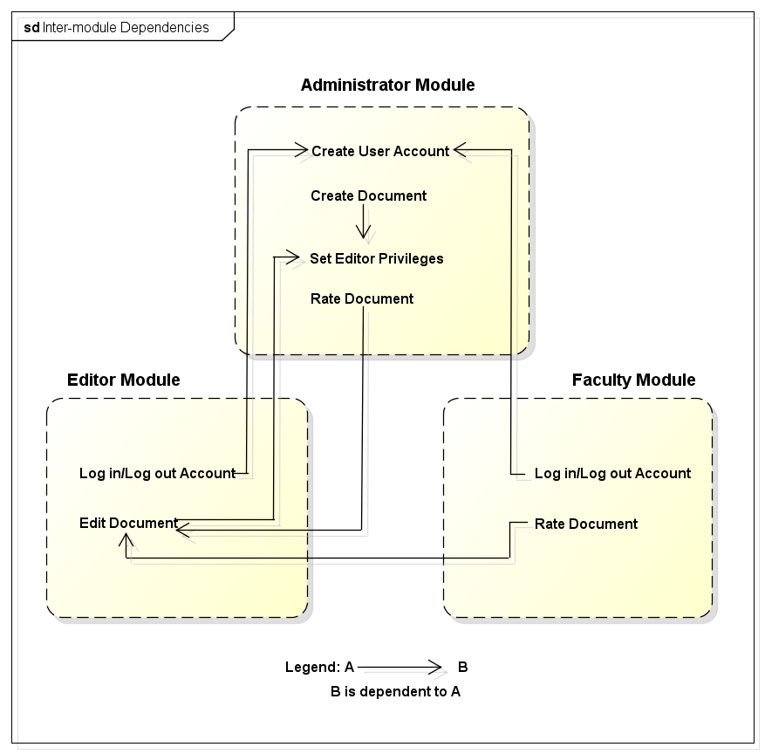
Figure 4.1 Inter-module Dependencies

Inter-process Dependencies
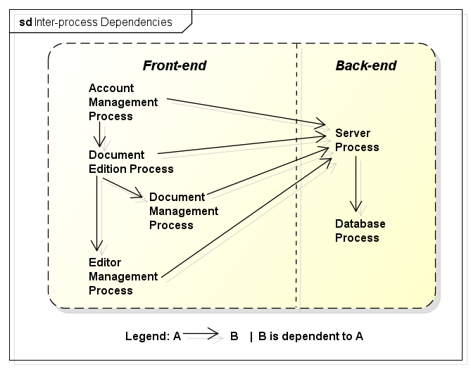
Figure 4.2 Inter-process Dependencies

Data Dependencies

Each entity has a relationship to each other. Some attributes/data of an entity in the system is needed by other entities. The user's id attribute is used as a foreign key by Project, Account, Document and Document Comment entities to access the User table in the database. The Project data are also used for the Document and Document Comment entities.

Interface Description

Module Interface

Administrator and Faculty Module Description

Sub-module: | Dashboard
Identification: | Home page
Type: | Table
Description: | This UI displays project, documents, editors, and faculties.
Table 5.1.1 Administrator and Faculty Module Description - Dashboard

Sub-module: | Project
Identification: | Project Page
Type: | Form and Table
Description: | This screen show to form to create project, change project leader, change instructor, add/delete member, search, and rename/delete project
Table 5.1.1 Administrator and Faculty Module Description-New Project Page Description

Sub-module: | Document
Identification: | Document Page
Type: | Form and fieldset
Description: | This shows the fieldsets to delete, insert, and rename document section; buttons to rate, block/unblock, and preview a section and document; view and add comments; view entire document and delete document
Table 5.1.1 Administrator and Faculty Module Description- Manage Document Page Description

Sub-module: | Manage Editor
Identification: | Manage Editor Page
Type: | Form and fieldset
Description: | This screen will show the fieldsets to add, delete member; change leader; change editors; reset password
Table 5.1.1 Administrator and Faculty Module Description- Manage Editor Page Description

Sub-module: | Manage User
Identification: | Manage User Page
Type: | Form and fieldset
Description: | This screen is just a group of fielsets to add new user; delete user or reset
Table 5.1.1 Administrator and Faculty Module Description- Manage User Page Description

Editor Module Description

Sub-module: | Edit
Identification: | Form (in PHP, JavaScript, JQuery embedded with CKEditor)
Type: | Form (PHP)
Description: | This will display the text editor for the user.
Table 5.1.2 Editor Module Description- Edit Tab Description

Sub-module: | View
Identification: | View tab
Type: | Form (PHP)
Description: | This will display the document section, rating, current editor, last edition, and last editor information
Table 5.1.2 Editor Module Description-View Tab Description

Sub-module: | Upload
Identification: | Upload Page
Type: | Form
Description: | This will display the upload installer, source code, ppt presentation, manual, and documentation form
Table 5.1.2 Editor Module Description- Upload Tab Description

Process Interface

First Log In Module Description
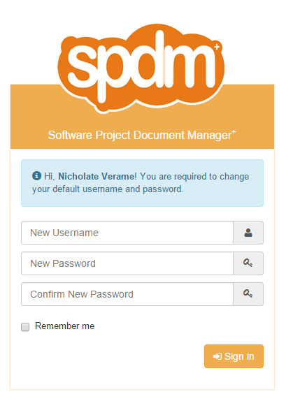
Figure 5.2.1 First Log In Module Description
This is where user sign in for the first time with their own username and password.

Log In Module Description

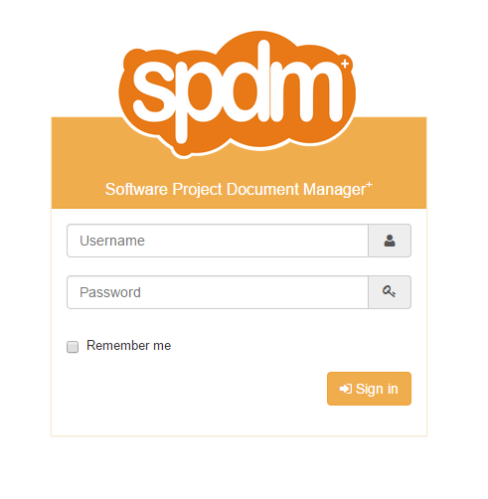
Figure 5.2.2 Log In Module Description
This is where admin, faculties, and users login using their username and password.

Create New Project Module Description
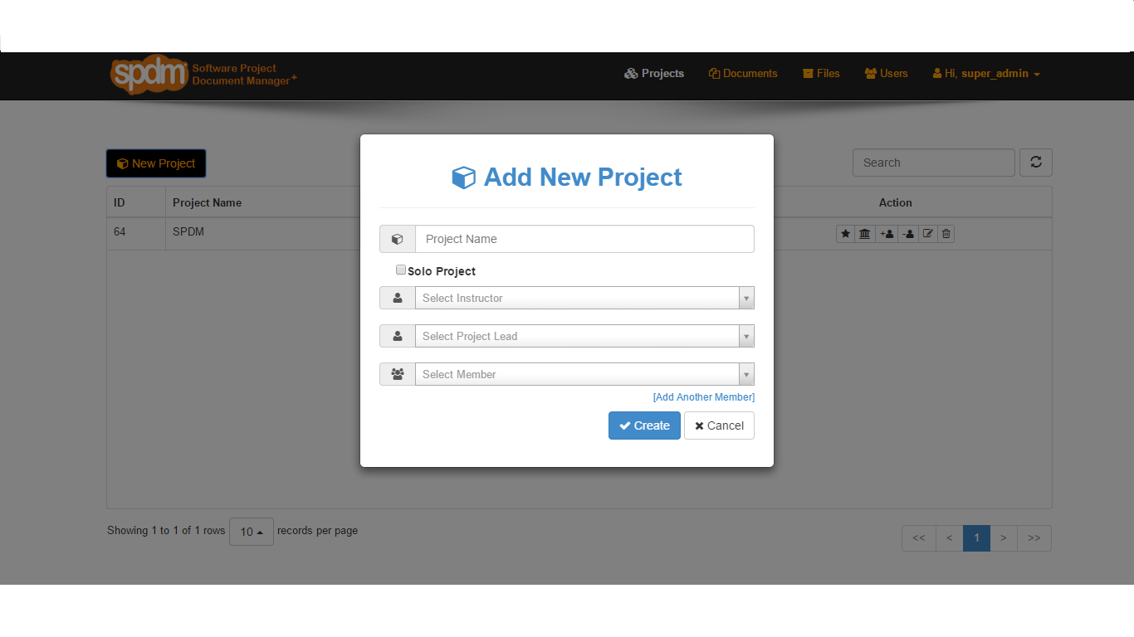
Figure 5.2.3 Create New Project Module Description
This is where the admin and faculties create new project and assign it to students/editor.

User Module Description
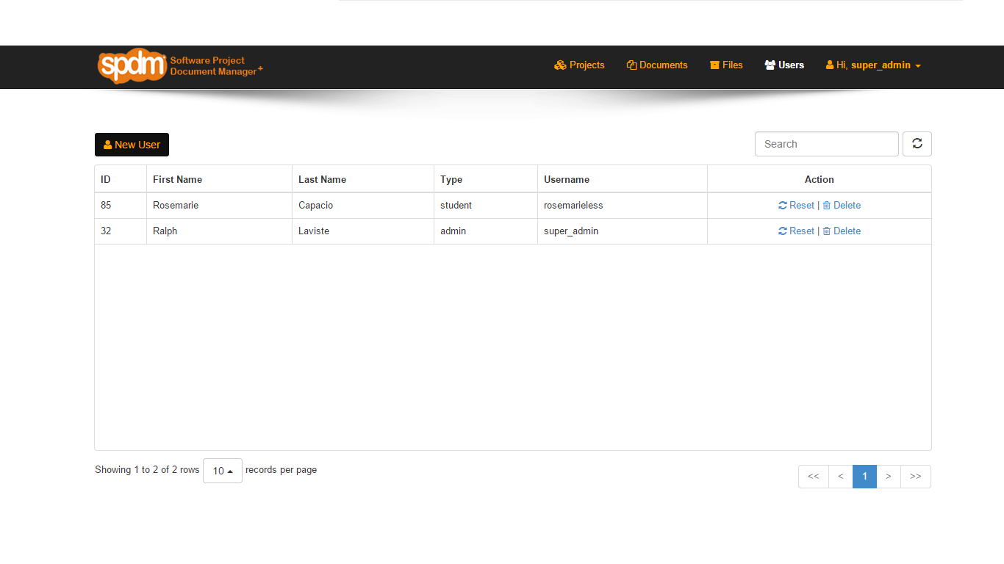
Figure 5.2.4 Add New User Module Description
This is where the admin and faculties add see all the users.

Add New User Module Description
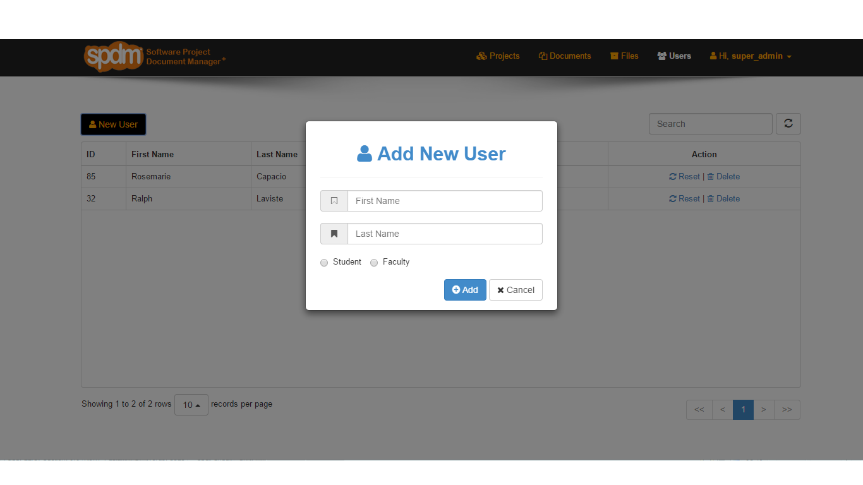
Figure 5.2.5 Add New User Module Description
This is where the admin adds new users.

Dashboard Module Description
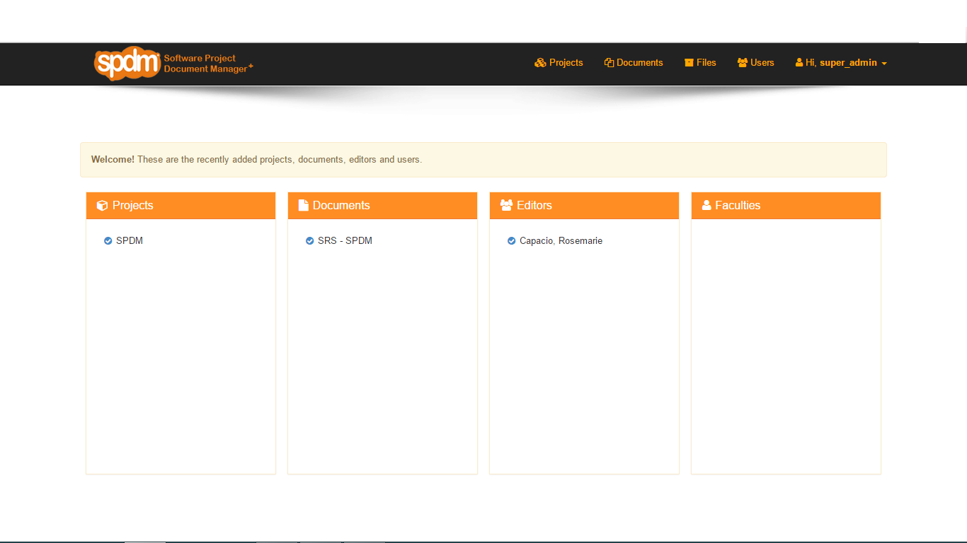

Figure 5.2.6 Dashboard Module Description
This is where the admin and faculties see all the projects, documents, faculties, and editors which comprise the entire system.

Project Module Description
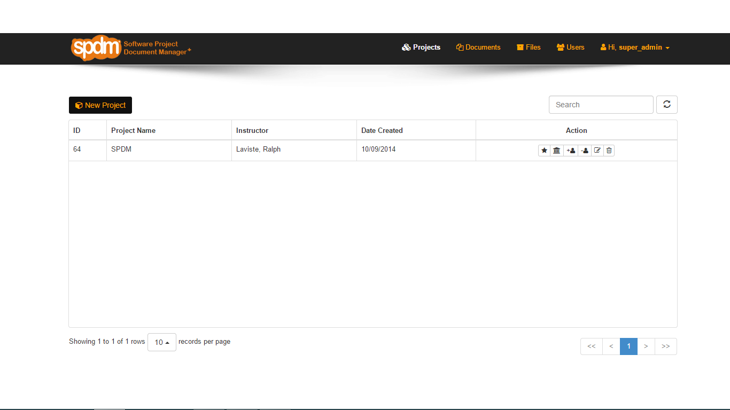
Figure 5.2.7 Project Module Description
This is the Project Module where the admin and faculties see all the projects.

Files Module Description
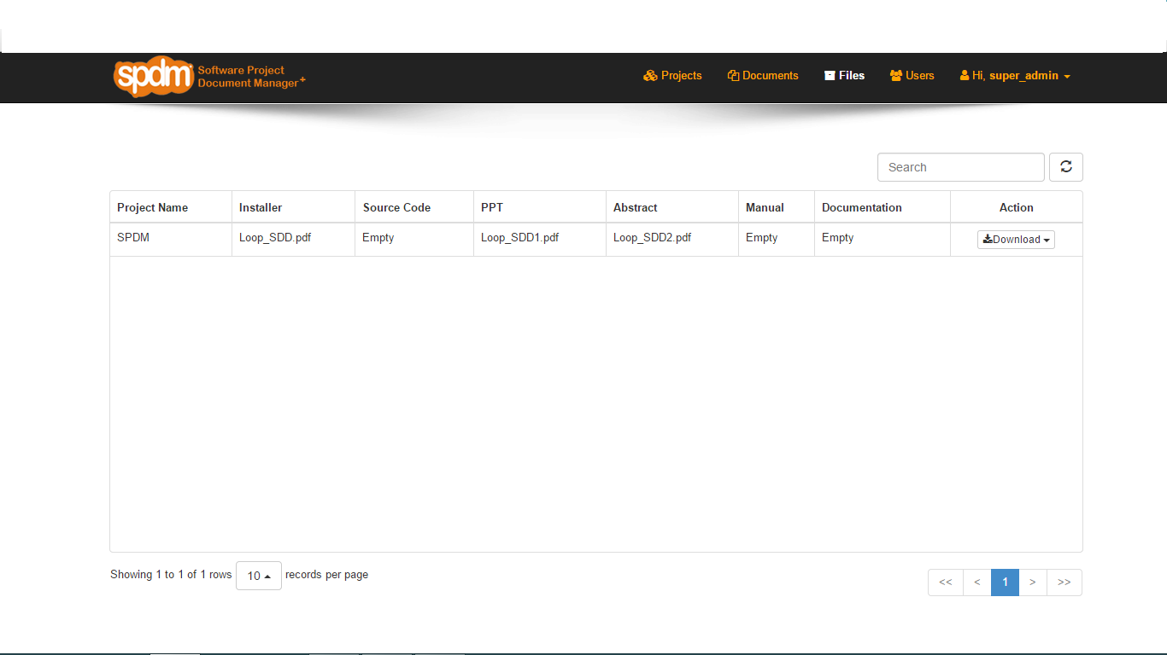
Figure 5.2.8 Files Module Description
This is the Files Module where the admin and faculties see all the projects files.

Download Files Module Description

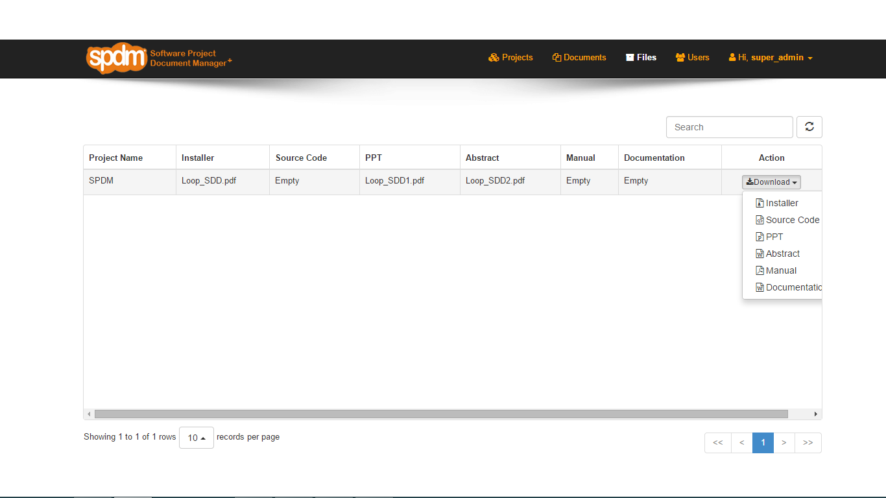
Figure 5.2.9 Download Files Module Description
This is the Download Files Module where the admin and faculties can download files.

Detailed Design

Module Detailed Design

Log In User Module Detail
Sub-module Name: Log In User
Description: This is where all users enter their username and password to access the system.
Operations:
Name: Log In
Arguments: username: String
password: String
Condition: User must have a valid username and password
Flow:
    - if user(not admin) logs in for the first time:
      - user should had been registered first by the admin then gets a default username and password which is the concatenation of the first name and last name and the password is "12345".
      - enters default user data
      - user is redirected to the Log In page which asks for the user to change default user data.
    - if already a registered user:
      - user enters username and password then clicks Log In button
Result:
- if user is admin/faculty:
      - System redirects admin/faculty to Dashboard.
    - if user is editor:
      - System redirects editor to Editor page.

Administrator and Faculty Module Detail
Sub-module Name: Dashboard
Description: This part describes the operations done by the administrator user-type on SPDM information display processes in the system.
Operations:
Name: Display Project, Document, Faculties, Editors, Files
Argument: void
Condition: Connected to SPDM DB, admin is logged in, admin is in Home page
Result: System directs admin to Dashboard page and display all information about project, documents, editors, faculties, and files.

Sub-module Name: Project
Description: This part describes the operations done by the administrator user-type on project creation processes of an editor in the system.
Operations:
Name: Create Project
Arguments: projectname: String
documentname: String
editorname: String[]
Condition: Connected to SPDM DB, admin is logged in, admin is in Administration page

Flow:
    - admin input project name, select instructor, leader and members
    - admin input document name, and select template
    - admin sets editors of the document.

Result:
    - System redirects admin to Project page.
    - Project, document, and editors saved.

Sub-module Name: Manage
Description: This part describes the operations done by the administrator user-type on document management processes of edited documents in the system.
Operations:
Name: Manage Document
Arguments: document_name: String
section_name: String
project_name: String
Condition: Connected to SPDM DB, admin is logged in, admin is in Management page
Flow:
    - Admin selects one document section on a combo box.
    - Admin deletes, inserts, and renames document section.
    - Admin rates, block/unblock for editing, and previews a section and document.
    - Admin views and adds comments; views document information

Result:
    - If admin clicks Preview, system shows a web PDF reader page with the preview of the entire document.
    - If admin clicks Save, system shows a dialog box to confirm Save/Cancel rating.
    - If user clicks Yes, system saves rating then redirects to Management page.
    - If user clicks No, system redirects admin to Management page.

Name: Manage Editor
Arguments: user_firstname: String, user_lastname: String
Condition: Connected to SPDM DB, admin is logged in, admin is in Management page
Flow: Admin assigns editors to edit sections of the documents;
Result: System shows a dialog box to confirm Add/Delete/Cancel.
If user clicks Yes, system adds new user/deletes user.
If user clicks No, system redirects admin to Management page.

Name: Manage User
Arguments: user_firstname: String, user_lastname: String
Condition: Connected to SPDM DB, admin is logged in, admin is in Management page
Flow: Admin add new user; delete user or project
Result: System shows a dialog box to confirm Add/Delete/Cancel.
If user clicks Yes, system adds new user/deletes user or entire project.
If user clicks No, system redirects admin to Management page.

Editor Module Detail

Sub-module Name: Edit
Description: This part describes the operations done by the editor user-type on document edition processes in the system.
Operations:
Name: Enter Group
Argument: groupName: String
Condition: Connected to SPDM DB, user is logged in, user has a group
Flow:
-User selects a group on combo box. If combo box has no value, meaning user has no group.
-User clicks Enter Group button
Result: -System directs user to the same page but only the sections he/she can edit are enabled.

Name: Save Document
Argument: ckEditorDoc: String
Condition: Connected to SPDM DB, user is logged in, user is in Editing page
Flow:
    - User clicks Save button
    - User select on dialog box wither to confirm Save or Cancel.
Result:
    - System shows a dialog box for save confirmation.
    - If user clicks Yes, system saves the document.
    - If user clicks No, system hides dialog box.

Name: Preview Document
Argument: void
Condition: Connected to SPDM DB, user is logged in, user is in Editing page
Flow: User clicks Preview button
Result: System shows a web PDF reader page with the preview of the entire document.

Sub-module Name: View
Description: This part describes the operations done by the editor user-type on edition log viewing process in the system.
Operations:
Name: View Log
Argument: void
Condition: Connected to SPDM DB, user is logged in, user is in Editing page
Flow: User clicks View Log button
Result: System directs user to the Log page and show edition log of him/her and groupmates.

Sub-module Name: Upload
Description: This part describes the operations done by the editor user-type on document uploading processes in the system.
Operations:
Name: Upload
Argument: installer: String, source code, abstract: String, presentation: String
Condition: Connected to SPDM DB, user is logged in
Flow:
    - User select link for a particular data to upload
    - User uploads the data
Result: System stores uploaded data to DB

Data Detailed Design

User Entity Detail

Storage Medium: mySql Database
Attribute | Data Type | Purpose
user_id | int | Primary key for querying purposes
username | String | One of the requirements to access the system
fname | String | Indicates the first name of the user
lname | String | Indicates the last name of the user
password | String | Will serve as secret key for accessing user’s account
type | String | Will determine what type of user(admin, faculty, editor)
Table 6.2.1 User Entity Detail

Project Entity Detail

Storage Medium: mySql Database, upload_files folder
Attribute | Data Type | Purpose
project_id | int | Primary key for querying purposes
project_name | String | One of the requirements to access the system
instructor | int | Foreign key from spdm_user table that indicates the instructor of the Project
installer | String | Name of the installer file corresponding the document
source_code | String | Name of the source code file corresponding the document
presentation | String | Name of the powerpoint presentation file corresponding the document
manual | String | Name of the manual file corresponding the document
abstract | String | Name of the abstract file corresponding the document
documentation | String | Name of the documentation file corresponding the document
Table 6.2.2 Project Entity Detail

Document Entity Detail

Storage Medium: mySql Database, upload_files folder
Attribute | Data Type | Purpose
document_id | int | Primary key for querying purposes
document_name | String | Name of the document of the project
project_id | int | Foreign key from spdm_project table that indicates to the project it belongs
state | int | if document is already published, value = 1; otherwise 0
Table 6.2.3 Document Entity Detail

Document Template Entity Detail

Storage Medium: mySql Database
Attribute | Data Type | Purpose
template_id | int | Primary key for querying purposes
template_name | String | Name of the document template
type | String | Templates are classified into: ('srs_template', 'spmp_template', 'sdd_template', 'std_template', 'custom_template'
level | int | Level of the document template
Table 6.2.4 Document Template Entity Detail

Document Section Entity Detail

Storage Medium: mySql Database, upload_files folder
Attribute | Data Type | Purpose
section_id | int | Primary key for querying purposes
section_name | String | One of the requirements to access the system
document_id | int | Foreign key from spdm_document table that indicates the document to which the section belongs
level | int | Foreign key from spdm_document_template table that indicates the template to which the section belongs
editor | int | Foreign key from spdm_user table that indicates the editor of the section
state | String | values: edited or unedited
rating | String | Rating of the section/document from the faculty/admin.
content | String | Data input of the user in CKEditor when he/she is editing
last_edtion_date | datetime | Indicates the time when the section/document was edited.
last_editor_name | String | Indicates the name of the editor
Table 6.2.5 Document Section Entity Detail

Document Comment Entity Detail

Storage Medium: mySql Database
Attribute | Data Type | Purpose
comment_id | int | Primary key for querying purposes
author | int | Foreign key from spdm_user table that indicates the faculty/admin who gives the comment
date | datetime | Indicates the time when the comment was created
comment | String | The content of the comment
reference_doc | int | Foreign key from spdm_document table that indicates the document of the section
reference_section | int | Foreign key from spdm_doc_section table that indicates the section of the document being commented
Table 6.2.6 Document Comment Entity Detail

Project Member Entity Detail

Storage Medium: mySql Database
Attribute | Data Type | Purpose
member_id | int | Primary key for querying purposes
project_id | int | Foreign key from spdm_project
user_id | int | Foreign key from spdm_user
type | String | The type of member: ('leader', 'editor')
Table 6.2.7 Project Member Entity Detail
- Annexes

7.1. Class diagram (if any)
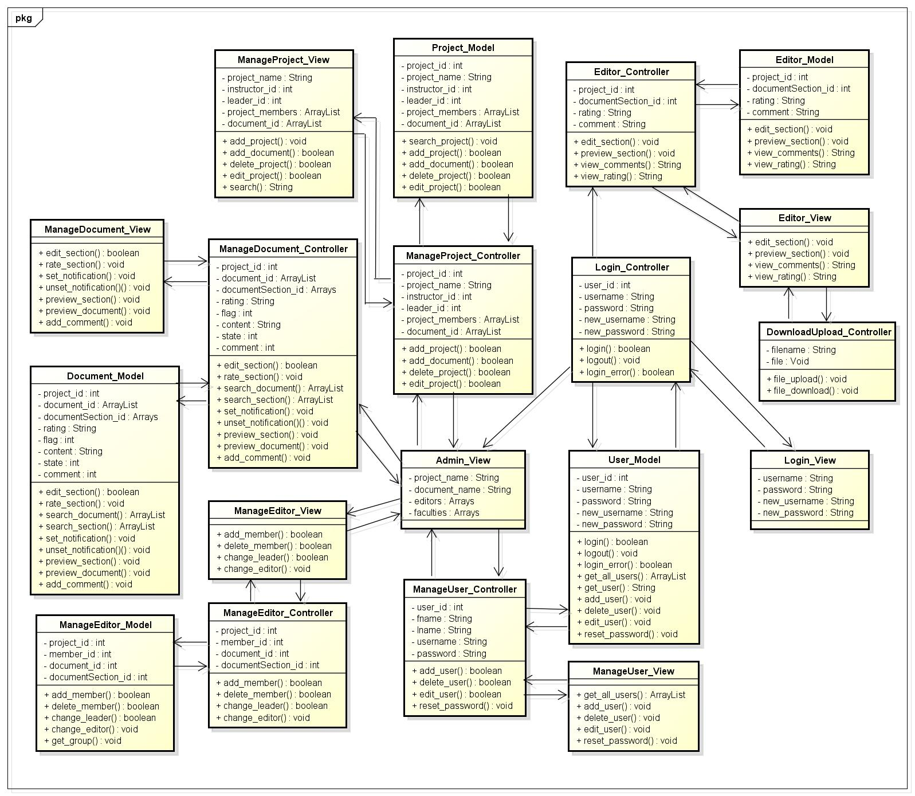

7.2. Sequence diagram / Communication diagram (if any)

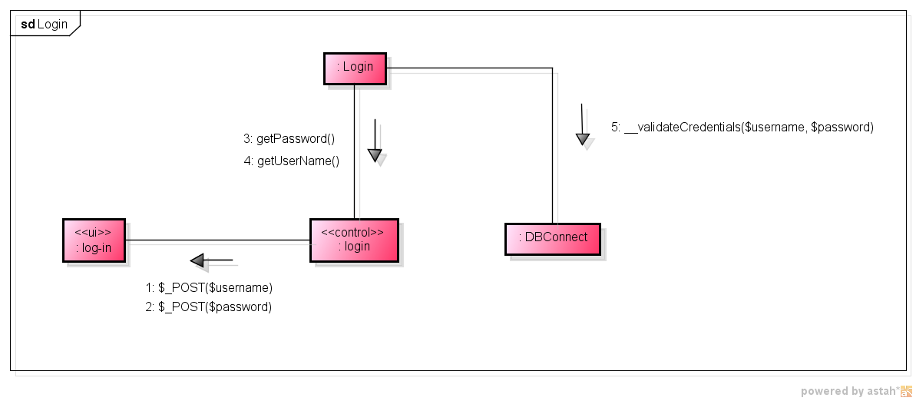
Figure 3: Log-in Communication Diagram

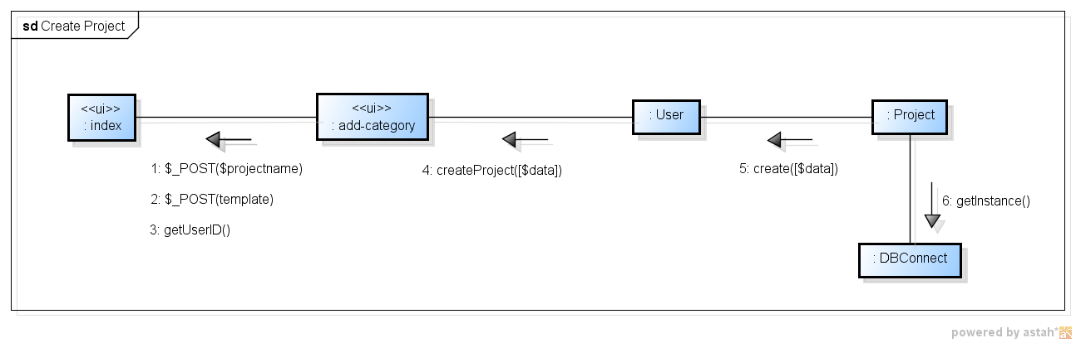

Figure 4: Create a Project Communication Diagram

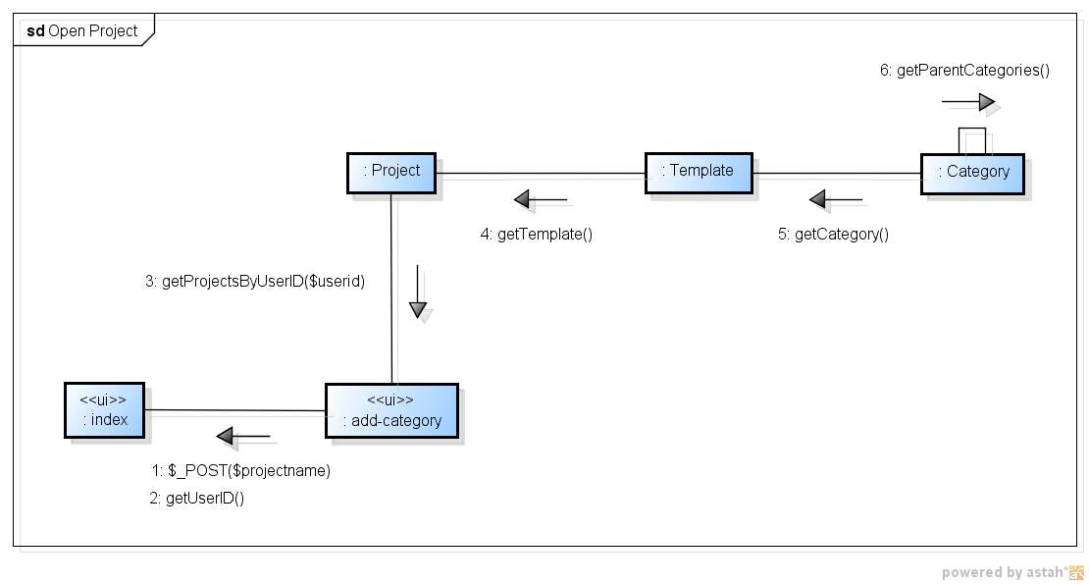
Figure 5: Open a Project Communication Diagram

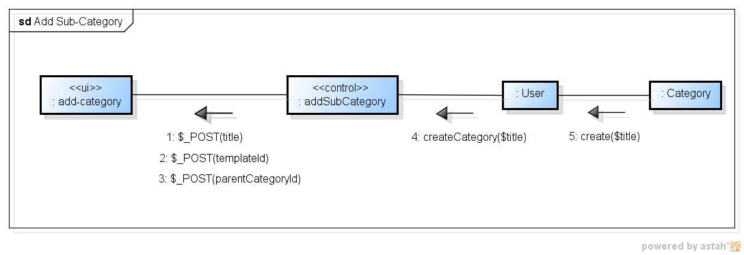
Figure 6: Add Sub-content Communication Diagram

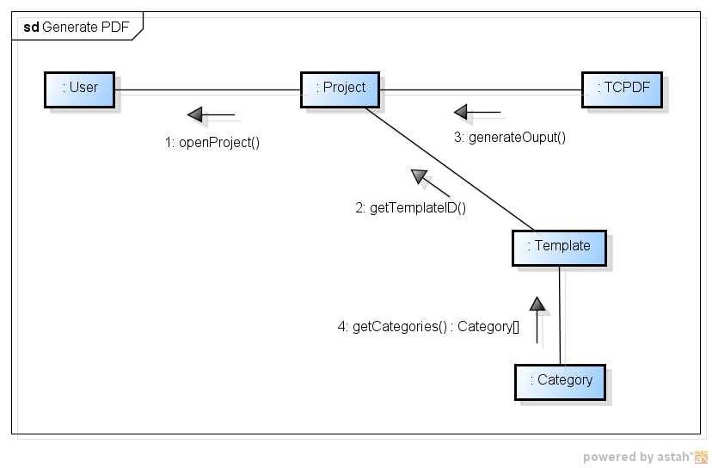

Figure 7: Generate PDF Communication Diagram

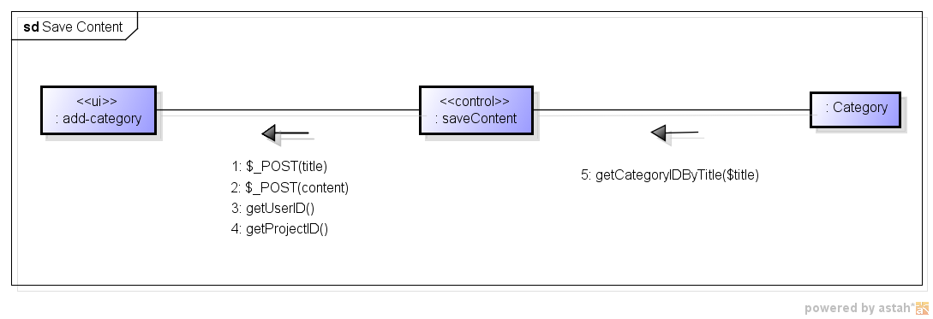
Figure 8: Save Content Communication Diagram

7.3. Entity relationship diagram (if any)

